Kimono Desktop

Installation on macOS with Google Chrome

# Install Desktop App

Download the Desktop Application from the [GitHub Repository](https://github.com/sdsu-its/Kimono) (sdsu-its/Kimono). Uncompress the folder, and move it to your Applications folder. Open the application, note you may need to modify the Gatekeeper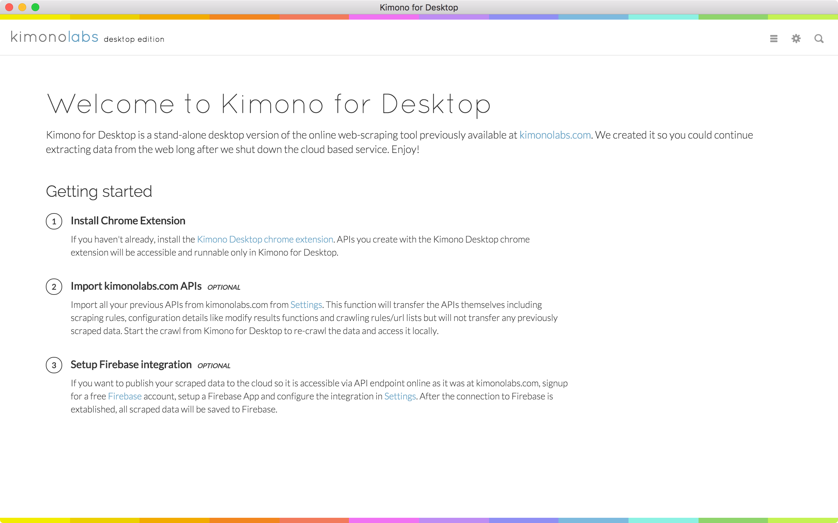 setting in System Preferences > Security & Privacy to get the application to open. You will be prompted to install the Chrome Plugin. Use the steps below, rather than following the link, as the link is broken.

You may also get an error message regarding SSL issues, this can also be safely disregarded, as we will not be connecting to the Kimono API.

# Install Chrome App

Kimono has discontinued listing their extension in the Chrome Extension Web Store, so we will need to load the extension as a developer plugin.

## Download

We will first need to download the plugin file, which can be downloaded from the [GitHub Repository](https://github.com/sdsu-its/Kimono) (sdsu-its/Kimono).

Next, you will need to decide where to save the plugin. *Chrome will NOT copy the plugin when you load it, it will only create a link to the folder*. To avoid any issues, and accidental deletion, we can save the folder along side the other extensions, depending on how many profiles, if any, you have in Chrome, the file path will vary slightly. The base path is ~/Library/Application Support/Google/Chrome/. From that point, select either the correct Profile folder, or Default, and then Extensions. Move the folder that you downloaded, which may need to be uncompressed. Make note of the file path, as you will need it when you load the extension.

## Install

Enabling developer mode allows you to “Load unpacked extension”, which is how we will be loading the Kimono plugin. Click on “Load unpacked extension…” and then select the folder that we copied over in the previous step.

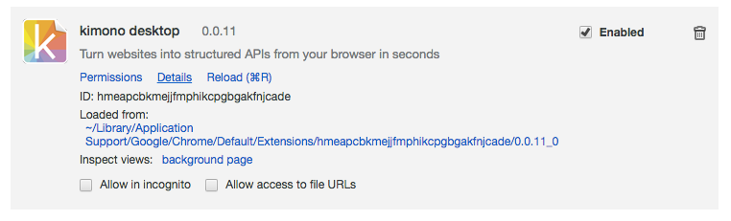

You should now see the Plugin listed and the Kimono Logo should appear in the Top Most Chrome Menu. You are now ready to use Kimono!